**Setting Up a DHT22 Temperature and Humidity Sensor to collect Data**

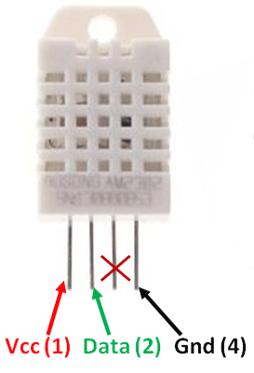

Reference Video: [**https://www.youtube.com/watch?v=EcyuKni3ZTo&t=116s**](https://www.youtube.com/watch?v=EcyuKni3ZTo&t=116s)

Install the adafruit DHT22 library. On the terminal run..

sudo pip3 install adafruit-circuitpython-dht

**Wiring Diagram DHT 22 AND LDR**

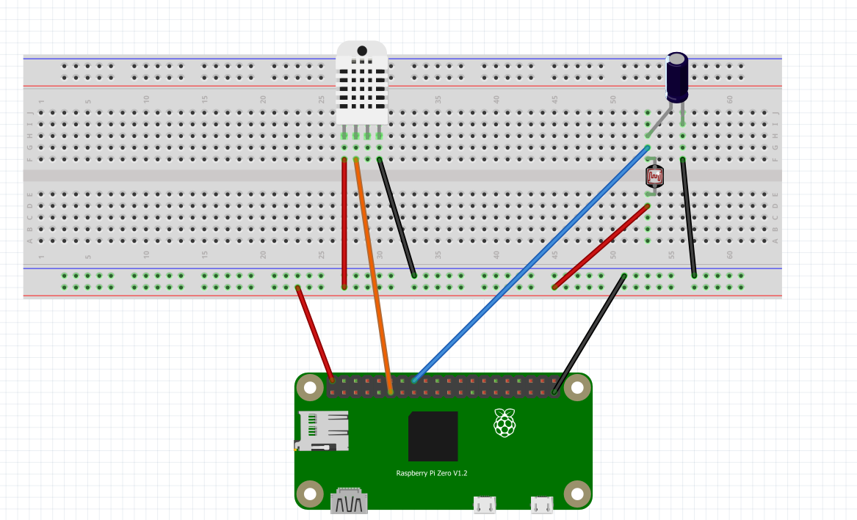

**PIN 18**

**PIN 17**

**V D X G**

**LDR**

**+ve**

**1uF Capacitor**

**Demo: dht22adafruit.py**

Other types of Temperature and Humidity Sensors, using different kinds of libraries can be used with the Raspberry Pi to.

The BME280 is another popular Temp/Humidity sensor.

Here is a video for the BME280.

<https://www.youtube.com/watch?v=ChQpD2gsC20>

**Setting Up an LDR to collect brightness Data**

<https://www.youtube.com/watch?v=IOyYQ34C2y0>

HOW LIGHT DEPENDENT RESISTORS (AKA PHOTORESISTORS) WORK.

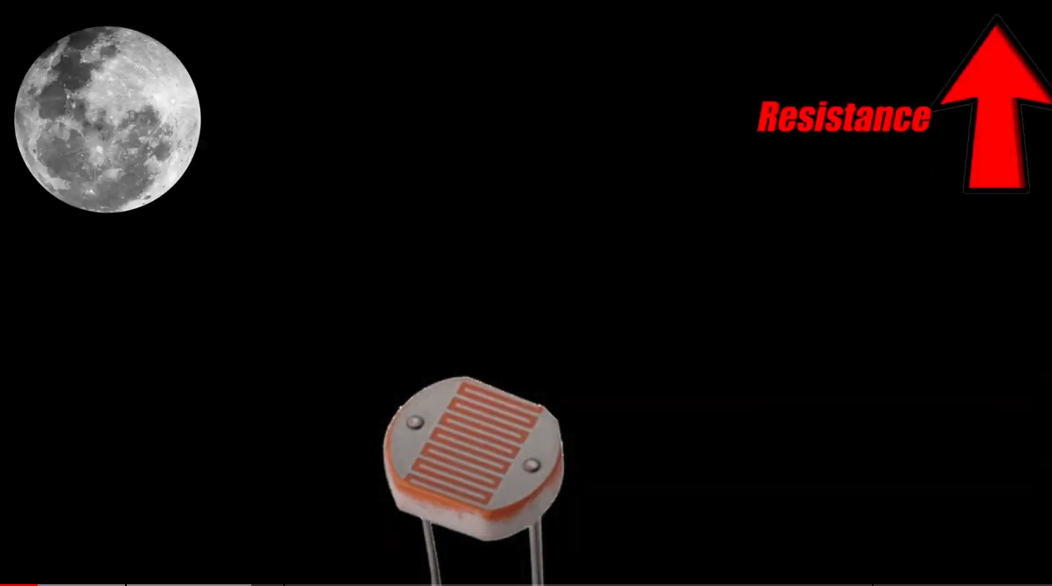

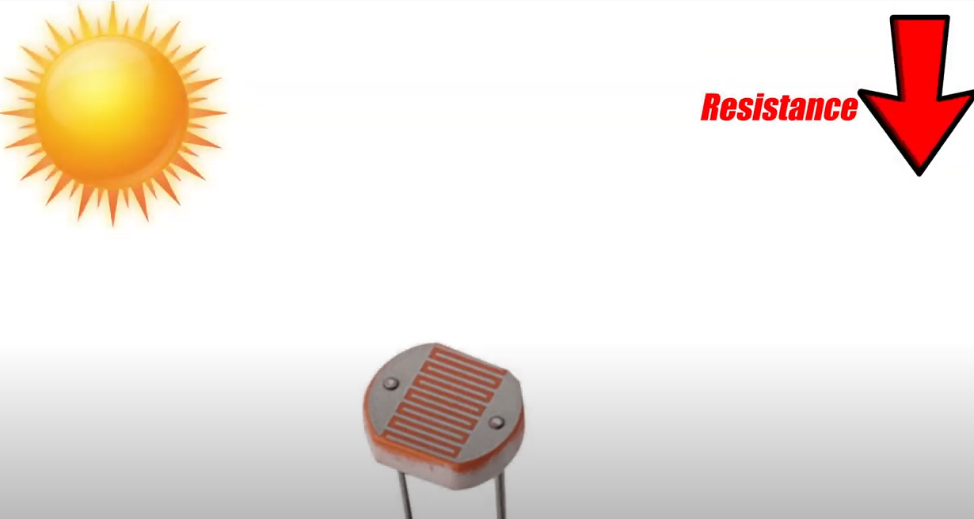

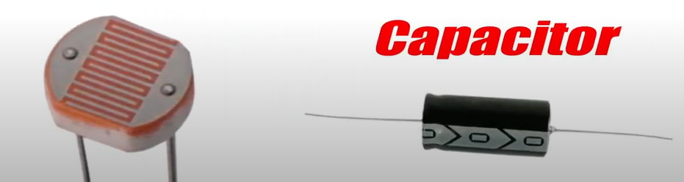

We can indirectly measure the amount of light by connecting a capacitor. The amount of time taken for the capacitor to charge depends on how much current is flowing through the LDR attached to it. The lower the resistance of the LDR the faster the capacitor gets charged. Vice versa. This way can indirectly tell the intensity of the light hitting the LDR.

**Demo : ldrtest.py**

**Putting them altogether**

Now that we able to get the temperature, humidity and light intensity of an environment we are monitoring, we can send these data to be recorded in the “cloud”

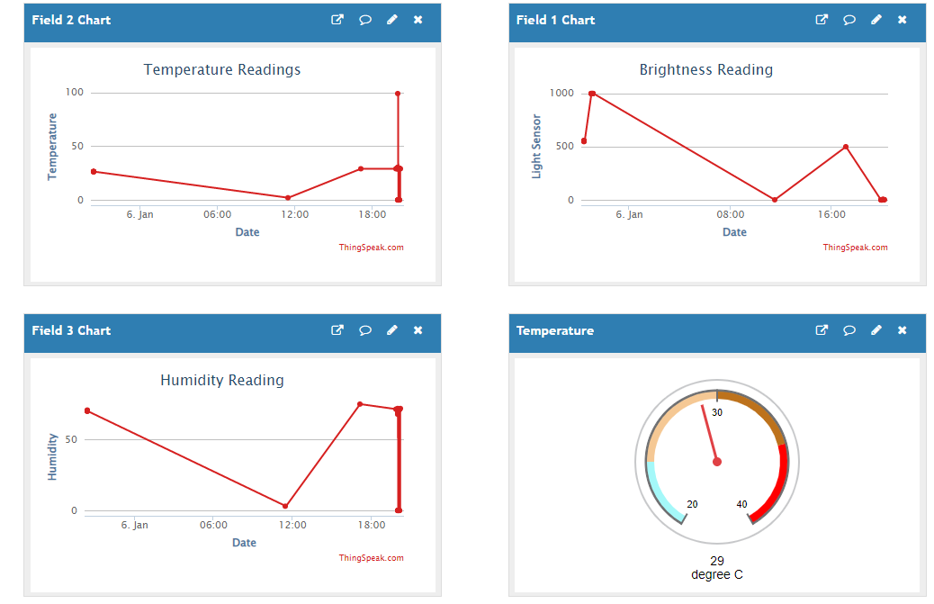

**Demo: sendtothingspeak.py**